SQL

DataWithBaraa
SQL DataWithBaraa

/*
CONVERT(): converts a data or time value to a different data type & formats the value
------------
-- syntax --
------------
CONVERT(data_type, value, style[optional])
style in CONVERT() controls how date/time or some numbers are formatted when converted to text
style is a number code that tells SQL server which data formats to use when converting date/time to string

-- data_type: usually VARCHAR or CHAR
-- value: date or time
-- style: format code
*/

USE SalesDB;

SELECT
CONVERT(VARCHAR, '123') AS [String to Int CONVERT],
CONVERT(DATE, '2025-08-20') AS [DateTime to Date CONVERT],
CreationTime,
CONVERT(DATE, CreationTime) AS [DateTime To Date CONVERT],
CONVERT(VARCHAR, CreationTime, 32) AS [USA Std. Style: 32],
CONVERT(VARCHAR, CreationTime, 34) AS [EURO Std. Style: 34]
FROM Sales.Orders;

/*
========================
== 34 CAST() Function ==
========================
- CAST(): converts a value to a specified data type

------------
-- syntax --
------------
- CAST(value AS data_type)
*/

USE SalesDB;

SELECT
CAST('123' AS INT) AS [String To Integer],
CAST(123 AS VARCHAR) AS [Integer To VARCHAR],
CAST('2025-08-20' AS DATE) AS [String To Date],
CAST('2025-08-20' AS DATETIME) AS [String To DateTime],
CAST('2025-08-20' AS DATETIME2) AS [String To DateTime2],
CAST(CreationTime AS DATE) AS [Datetime to DATE],
CAST(CreationTime AS VARCHAR) AS [Datetime to Varchar]
FROM Sales.Orders;
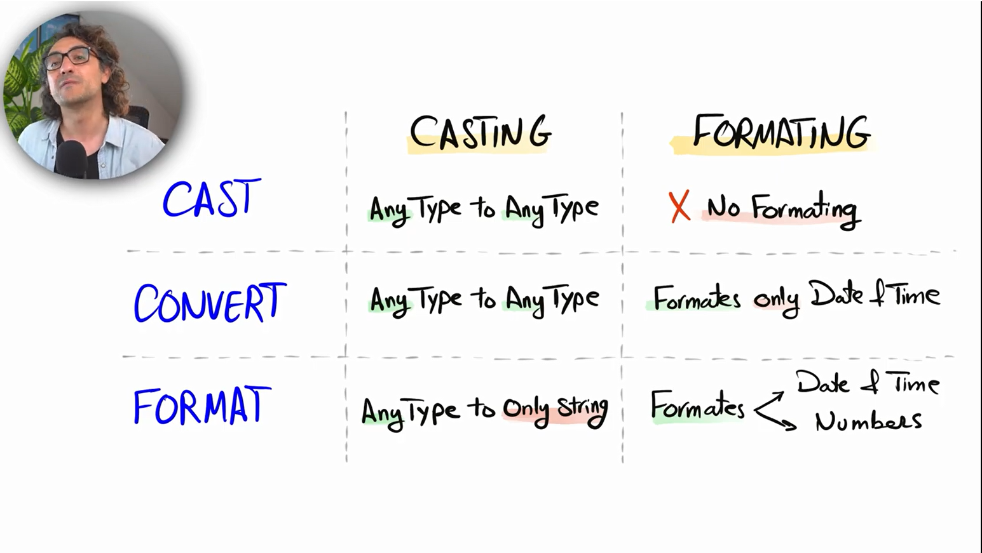

Difference Between FORMAT, CONVERT, CAST
Feature | CAST | CONVERT | FORMAT
SQL Standard | ✅ Yes (ANSI standard) | ❌ No (SQL Server specific) | ❌ No (SQL Server specific)
Main Purpose | Convert data type | Convert data type with style | Format output as string
Syntax | CAST(expr AS datatype) | CONVERT(datatype, expr, style) | FORMAT(expr, format, culture)
Style / Format Support | ❌ No | ✅ Yes (style codes like 101, 103…) | ✅ Yes (custom formats)
Output Data Type | Target data type | Target data type | Always NVARCHAR
Performance | 🚀 Fast | 🚀 Fast | 🐌 Slow (uses .NET CLR)
Best For | Simple conversions | Date/number formatting in SQL Server | Display/UI formatting
Culture Support | ❌ No | ❌ No | ✅ Yes (en-US, ar-EG, etc.)
Works With | Dates, numbers, strings | Dates, numbers, strings | Dates & numbers only
Recommended in WHERE/JOIN | ✅ Yes | ✅ Yes | ❌ No (bad performance)

-- CAST
SELECT CAST(GETDATE() AS DATE);

-- CONVERT
SELECT CONVERT(VARCHAR, GETDATE(), 103);

-- FORMAT
SELECT FORMAT(GETDATE(), 'dd/MM/yyyy', 'en-GB');

/*
================
== 35 DATEADD ==
================
- DATEADD(): is a SQL function used to add or subtract a time interval (days, months, years, etc.) to/from a date.

------------
-- syntax --
------------
DATEADD(datepart, interval, date)

Parameters:
datepart: the unit of time (year, month, day, etc.)
number: how many units tWo add (use a negative number to subtract)
date: the original date

| datepart | Meaning |
| ----------- | ------- |
| year / yy | Year |
| month / mm | Month |
| day / dd | Day |
| hour / hh | Hour |
| minute / mi | Minute |
| second / ss | Second |

*/
USE SalesDB;

-- add 10 days to 2026-01-29
SELECT
'2026-01-29',
DATEADD(day, 10, '2026-01-29');

-- subtract two months from 2026-01-29
SELECT
'2026-01-29',
DATEADD(month, -2, '2026-01-29');

-- add one year to 2026-01-29
SELECT
'2026-01-29',
DATEADD(year, 1, '2026-01-29');

-- Date after 30 days from today
SELECT
GETDATE(),
DATEADD(day, 30, GETDATE());

-- Calculates the delivery date 7 days after the order date.
USE MyDatabase;

SELECT
order_date,
DATEADD(day, 7, order_date) AS DeliveryDate
FROM Orders;

-- add one year to the CreationTime
USE SalesDB;
SELECT
CreationTime,
DATEADD(YEAR, 1, CreationTime) AS [Add One Year]
FROM Sales.Orders;

/*
=================
== 36 DATEDIFF ==
=================
- DATEDIFF() is a SQL function used to calculate the difference between two dates.
It returns the difference as an integer, based on the date part you specify (days, months, years, etc.).

allow us to find the differences between two dates

------------
-- syntax --
------------
- DATEDIFF(part, start_date, end_date)
*/

USE SalesDB;

SELECT
DATEDIFF(month, '2025-01-15', '2026-01-15') AS MonthsDifference;

-- how many days
SELECT
DATEDIFF(DAY, '2025-01-15', '2026-01-15') AS MonthsDifference;

-- calculate the age of employees
SELECT
BirthDate,
DATEDIFF(YEAR, BirthDate, GETDATE()) AS [Employee Age]
FROM Sales.Employees

/*
LAG() is a window (analytic) function in SQL that lets you look at a previous row’s
value in the same result set without using a self-join.

LAG(column_name, offset, default_value) OVER (PARTITION BY partition_column ORDER BY order_column)
*/

/*
find the average shipping duration in days for each month
shipping duration = OrderDate - ShipDate
*/
SELECT
MONTH(OrderDate) AS [Order Date],
AVG(DATEDIFF(DAY, OrderDate, ShipDate)) AS [Day to Ship]
FROM Sales.Orders
GROUP BY MONTH(OrderDate);

/*
find the number of days between each order and previous order
this question called -> 'time gap analysis'
*/
SELECT
OrderID,
OrderDate AS [Current Order Date],
LAG(OrderDate) OVER (ORDER BY OrderDate) AS [Previous Order Date],
DATEDIFF(DAY, LAG(OrderDate) OVER (ORDER BY OrderDate), OrderDate) AS [Number of Days]
FROM Sales.Orders;

/*
============
== ISDATE ==
============
- ISDATE() is a SQL Server function that checks whether a given expression can be converted to a valid date.
It’s useful for validating data before doing date operations.

------------
-- syntax --
------------
ISDATE(expression)

*/

SELECT
ISDATE('2026-01-31'),
ISDATE('31-01-2026'),
ISDATE('hello');

/*
====================
== NULL Functions ==
====================
- NULL means no value / unknown / missing value.
- NULL is not equal to anything
- It does NOT mean: 0, empty string '', space ' ', It literally means “there is nothing here”.

--------------
-- ISNULL() --
--------------
- ISNULL() is a SQL Server function used to replace NULL with a value you choose.

----------------
-- COALESCE() --
----------------
- COALESCE() returns the first NON-NULL value from a list of expressions.

syntax
COALESCE(value1, value2, value3, ...)
*/

USE SalesDB;

SELECT ISNULL(NULL, 0) AS [Result]; -- Result: 0
SELECT ISNULL(NULL, 'N/A') AS [Result]; -- Result: N/A
SELECT ISNULL(NULL, NULL) AS [Result]; -- Result: NULL

SELECT COALESCE(NULL, NULL, 10) AS [Result]; -- Result: 10
SELECT COALESCE(NULL, 'A', 'B') AS [Result]; -- Result: A

SELECT COALESCE(NULL, NULL, 0) AS [Result]; -- INT
SELECT COALESCE(NULL, NULL, 'text') AS [Result]; -- VARCHAR

-- Show customer name and score. If score is NULL, show 0.
SELECT
first_name,
ISNULL(score, 0) AS score
FROM customers;

-- Missing country, If country is NULL, show 'Unknown'.
SELECT
first_name,
ISNULL(country, 'Unknown') AS country
FROM customers;

-- Fix messy names. Trim the name and replace NULL with 'No Name'.
SELECT
ISNULL(LTRIM(RTRIM(first_name)), 'No Name') AS first_name,
country,
score
FROM customers;

-- Math with ISNULL(). Add 50 bonus points. If score is NULL treat it as 0.
SELECT
first_name,
score,
ISNULL(score, 0) + 50 AS score_with_bonus
FROM customers;

-- Filtering with ISNULL. Show customers with score < 500. (Treat NULL score as 0).
SELECT
first_name,
country,
score
FROM customers
WHERE ISNULL(score, 0) < 500;

-- Grouping + ISNULL (important!). Show average score per country
SELECT
country,
AVG(ISNULL(score, 0)) AS avg_score
FROM customers
GROUP BY country;

-- Replace NULL score. If score is NULL, show 0.
SELECT
first_name,
COALESCE(score, 0) AS score
FROM customers;

-- Multiple fallbacks (very realistic). If first_name is NULL -> use 'Unknown'.
SELECT
COALESCE(first_name, 'Unknown') AS first_name,
country,
score
FROM customers;

-- Clean names + COALESCE. Some names have spaces (' John', ' hassan ').
SELECT
COALESCE(NULLIF(LTRIM(RTRIM(first_name)), ''), 'No Name') AS clean_name,
country,
score
FROM customers;

-- COALESCE in math
SELECT
first_name,
score,
COALESCE(score, 0) + 100 AS bonus_score
FROM customers;

-- Filtering with COALESCE. Show customers with score < 500 (NULL = 0).
SELECT
first_name,
country,
score
FROM customers
WHERE COALESCE(score, 0) < 500;

-- Grouping + COALESCE. Average score per country (NULL = 0).
SELECT
country,
AVG(COALESCE(score, 0)) AS avg_score
FROM customers
GROUP BY country;

/*
Why COALESCE is better here
- Works in all databases
- Handles multiple options
- Safer data types than ISNULL
*/

-- find the average scores of the customers
USE MyDatabase;

SELECT
id AS [customer id],
score,
COALESCE(score, 0) AS [score 2],
AVG(score) OVER() AS [Average Score],
AVG(COALESCE(score, 0)) OVER() AS [Average Score 2]
FROM customers;
-- handle the NULL befoe doing any mathematical operations
SELECT
5 + NULL, -- Result = NULL
5 + 5, -- Result = 10
'A' + 'B', -- Result = AB
'A' + NULL -- Result = NULL

/*
display the full name of customers in a single filed by merging their first and last name
and add 10 bonus points to each customer's score
*/
USE SalesDB;

SELECT
CustomerID,
FirstName,
LastName,
FirstName + ' ' + COALESCE(LastName, '') AS [Full Name],
score as [score],
COALESCE(score, 0) + 10 AS [score with bonus]
FROM sales.Customers;

/*
--------------------------------------------
-- handle the NULL before doing any JOINS --
--------------------------------------------
if there are any NULL values inside any table, will loss the record at the output
therefore must handle the NULL before doing any JOINS
*/

Feature | ISNULL() | COALESCE()
Type | SQL Server function | ANSI SQL standard
Portability | ❌ SQL Server only | ✅ Works in most DBs
Number of arguments | 2 only | 2 or more
Returns first non-NULL | ❌ (only checks 1 value) | ✅
Data type handling | Returns type of 1st argument | Uses data type precedence
Allows all NULL constants | ✅ | ❌ (needs typed expression)
Performance | Slightly faster (SQL Server) | Slightly slower (negligible)

